PROJECT REPORT

**ONLINE**

**ICE CREAM**

**PARLOUR**

**Purpose of the Project**

**The purpose of an icecream parlour website project would be to create an online presence for the business and to provide information to potential customers about the icecreams flavours , toppings, and others products that the parlours offers.**

**The website could also be used to showcase the parlours ambiance and provide information about events or promotions. Addtionally, it could be used to facilitate online ordering and delivery services, allowing customers to place orders for their favourite ice cream flavours and have them daelivered directly to their doorstep.**

**Overall, the purpose of an icecream palour website project is to increase brand awareness , reach a wider audience , and provide customers with an easy and convenient way to access the products and services that the parlour offers.**

**Scope of the Project**

**The scope of an icecream website would depend on the specific requirements of the business . However , some common features that could be included in the website are :**

**Home Page: This page would provide an overview of the icecream palour , its history and the type of products and services it offers .**

**Menu Page: This page would list all the icecream flavours , toppings, and other products that the palour offers . It could also include information about the nutritional value of each product.**

**Online Ordering Page: This page would allow customers to place orders online, select the prefered flavours and toppings , and pay for theirs orders.**

**Contact page: This page would provide the palour’s contact information, including its address ,phone number, email address ,and social media handles.It could also include a contact form that customers could use to send messages to the parlour.**

**About us page: This page would provide more detailed information about the palour’s history , mission , and values . It could also include information about the parlour’s staff , their qualification and their expertise.**

**Gallary page: This page would showcase photos and videos of the palour, its products, and its events. This would give potential customers a visual representation of what they can expect when they visit the palour.**

**The scope of an icecream palour website could be expanded to include additional features such as customers reviews , loyalty programs, gift cards, and social media integration. The key is to insure that the website is user friendly, informative , and visually appealing, while also meeting the needs of the icecream parlour and its customers.**

**.**

**Requirements of Owner of this project**

**An ice cream palour website is needed for several resources.**

**Online Presence: Having a website provides an online presence for the ice cream palour . With a website , customers can find information about the palour, including its location, hours of operation, menu,and pricing . They can also place online orders , which is convenient for customers who cannot visit the parlor in person.**

**Increased Visibility: A website also increases the visibility of the ice cream parlour .With search engine optimization(SEO), the website can rank higher on search engine like google, making it eadier for customers to find the palour online.**

**Marketing: A website is a powerful marketing tool. The palour can use its website to promote new products, offer discounts, and run special promotions to attaract more customers.**

**Customer Engagements: A website allow the icecream palour to engage with customers in a variety of ways . Customers can leave reviews and feedback,sign up for newsletters , and follow the palour’s social media accounts.**

**Cost-effective: Having a website is cost effective comapred to traditional advertising methods. The palour can reach a wider audience at a lower cost with a website.**

**Overall, an ice cream palour website is a valuable assets that can help attaract more customers, increases revenue and enhances the overall customers experince.**

**References**

**Idea Generation: Idea for the ice cream palour website has been generated , by looking at many website over the internet .**

**Design Samples: Sample of design is take from many different websites,**

**Contents: Homepage.Icecream page, cake page, order page, about and contact page.**

**Error Solutions: Many error occrured while making the website such as: making it responsive, using javascripts that prints error on console,many more css errors.**

**But for all , google has every solution for any error.**

**Tutorials: Youtube tutorails of css and javascripts by web developrs.**

**Guidance: Under the teacher guidance.**

**Resources:**

**Images: From- pixels,.com, pixabay.com , and unsplash.**

**Pages: Home page , Icecream page , Flavour page , Cake page, Order page , About page and Contact page.**

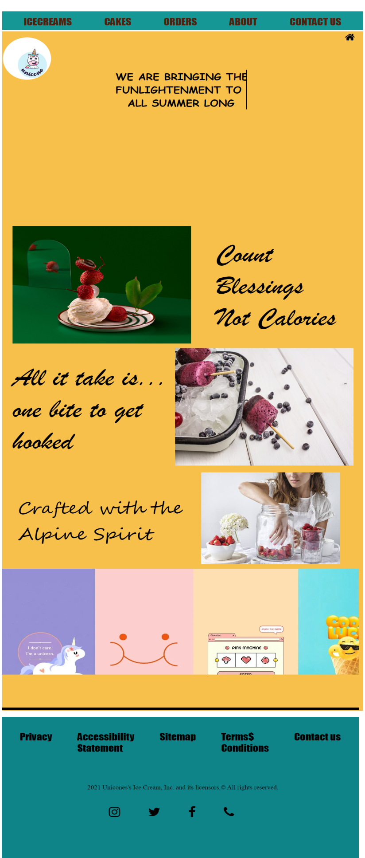

**Home page: SCREENSHOT**

HEADER

SECTION-1

ID: main1

SECTION-2

ID: animation

FOOTER

**CODING**

<!DOCTYPE html>

<html>

<head>

<title>Homepage</title>

<style type="text/css">

#main1 { height : 900px ; width: 100% ; }

#main { height: 50px; width: 50px; transform: translate(20px,-120px); }

#pr{text-align: center; /*color: white ;*/font-family: Comic Sans MS ; transform: translate(-4px,100px);font-size: 40px;/*border: 2px solid blue;*/}

#main2{background:#159895;border: 2px;width: 200px;height: 80px;/*border: 2px solid black;*/}

ul{display: flex; padding: 20px; justify-content: space-around; list-style-type:none; font-family: Impact; font-size: 40px;}

ul li a{text-decoration: none; color: #4F200D;}

ul li a:hover{background: #EAC7C7;}

/*#i{transform : translate(1100px,300px);}

#e{height: 190px; width: 170px;}*/

#t{height: 180px; width: 180px;border-radius: 100px;/*border: 2px solid black;*/transform: translate(-17px,-150px);}

#r{transform: translate(1000px,-170px); font-size: 50px;/*border: 2px solid black;*/}

#in{transform: translate(1100px,-170px); font-size: 50px; /*border: 2px solid black;*/}

#co{transform: translate(1200px,-170px); font-size: 50px; /*border: 2px solid black;*/}

#img1{Width : 100%; Height : 500px; margin-top : 70px; /*border: 2px solid red;*/}

#img1:hover{box-shadow: 0 0 0 10px #000000; transition: .5s ease;}

#foot{/*border: 2px solid black; */background: #D8BFD8; height: 300px; transform: translate(2px,90px);}

#hr{transform: translate(6px,30px); border: 2px solid black;}

#div1{/*border: 2px solid black;*/ transform: translate(910px,-350px); height:450px; width: 400px;}

#pa1{font-size: 60px; padding: 10px; font-family: Segoe Script; transform: translate(-800px,-180px);/*border: 2px solid black;*/width: 300pxcolor: #3A98B9;}

#apple{font-size: 50px; transform: translate(320px,-140px);color: maroon; /*border: 2px solid black;*/}

#kk{transform: translate(-120px,50px);/*border: 2px solid red;*/width: 60%;}

#k{/*border: 2px solid red; */transform: translate(0px,40px);}

tech-slideshow{margin: 0 auto; position: relative; overflow: hidden; height: 450px; width: 100%;/*border: 2px solid red;*/transform: translate3d(0, 0, 0);}

.tech-slideshow > div {height: 200px; width: 2526px; background: url(<https://imgv3.fotor.com/images/blog-richtext-image/combination-of-cute-lock-screen-wallpapers.jpg>); position: absolute; top: 0;left: 0;height: 100%;transform: translate3d(0, 0, 0);}.tech-slideshow .mover-1 {animation: moveSlideshow 12s linear infinite;}

.tech-slideshow .mover-2 {opacity: 0;transition: opacity 0.5s ease-out;background-position: 0 -200px;animation: moveSlideshow 15s linear infinite;}

.tech-slideshow:hover .mover-2 {opacity: 1;}

@keyframes moveSlideshow {100% {transform: translateX(-66.6666%);}}

@import url('https://fonts.googleapis.com/css2?family=Play&display=swap');

.wrapper.four {/*background-color: #9ba5b4;*/font-size: 3rem;font-family: "Play", sans-serif;}

.four .type{padding: 2rem 1rem;width: auto;margin: auto;}

.four h1 {width: 20ch; border-right: 4px solid black; margin: 2rem auto;white-space: nowrap;overflow: hidden;animation: typing 2s steps(13, end), blink-caret 0.5s step-end infinite alternate;}

@-webkit-keyframes typing {from {width: 0;}}

@-webkit-keyframes blink-caret {50% {border-color: transparent;}}

#animation{height: 500px;width:99%;left: 0;

position: absolute;background-size: 100% 100%;transform: translate(7px,0px);

animation-name: start;animation: slider 20s infinite linear;

}

@keyframes slider{0%{background-image: url(<https://cdn.pixabay.com/photo/2019/01/14/17/25/mango-3932597_960_720.jpg)>;}

25%{background-image: url(https://as2.ftcdn.net/v2/jpg/02/94/31/13/1000_F_294311319_l3B1N8PWSPz7fUvkGcsDpiKdk7RipmIQ.jpg );}

75%{background-image: url(https://cdn.pixabay.com/photo/2023/03/12/23/11/ice-cream-7848059__340.jpg );}

100%{background-image: url(https://t3.ftcdn.net/jpg/05/64/02/34/240_F_564023464_RaZb95D8yFPt2DnxbsYLQaQQ5BSrUImO.jpg );}}

</style>

<!-- <link rel="stylesheet" href="https://cdnjs.cloudflare.com/ajax/libs/font-awesome/4.7.0/css/font-awesome.min.css"> -->

<link rel="stylesheet" type="text/css" href= "https://maxcdn.bootstrapcdn.com/font-awesome/4.4.0/css/font-awesome.min.css">

<link rel="stylesheet" type="text/css" href="https://cdnjs.cloudflare.com/ajax/libs/font-awesome/4.7.0/css/font-awesome.min.css">

</head>

<body>

<div id="most">

<div id = "main1">

<div id="main2">

<ul>

<li><a href="ppp.html">ICECREAMS</a></li>

<li><a href="cakes.html">CAKES</a></li>

<li> <a href="orders.html">ORDERS</a></li>

<li> <a href="about.html">ABOUT</a></li>

<li> <a href="contact.html">CONTACT US</a></li>

</ul>

<!-- <div id="i">

<img src="q.jpg" id="e">

</div> --></div>

<i class="fa fa-home" style="float: right;margin-right: 20px; padding: 10px; font-size: 40px;"></i><div style=" height: 2890px; width: 100%; margin-top: 5px; background: #F7C04A;">

<div class="wrapper four"><div class="type"><h1 class="typing" id="pr">WE ARE BRINGING THE <br> FUNLIGHTENMENT TO YOU,<br> ALL SUMMER LONG</h1></div></div>

<div id = "main">

<img src= "logo.jpg" id="t">

</div>

<div id="animation"><!-- <img src="n1.jpg" id="img1"> --><div id="best" style="height: 2000px; "><!-- <div><img src="na.jpg" style="transform: translate(50px,10px); height: 300px; width: 43%;"></div> -->

<div><img src="na2.jpg" style="float: right; transform: translate(-70px,1500px);"></div>

<div><p style="font-size: 70px; transform: translate(60px,1600px); width: 50%; font-family: Segoe Script;">Crafted with the <br> Alpine Spirit</p></div>

<div><img src="art.jpg" class="ar" style="transform: translate(40px,160px); width: 50%; height: 500px;"></div>

<div><p style="font-size: 110px; font-family: Brush Script MT; transform: translate(800px,-400px); width: 35%; ">Count Blessings <br> Not Calories</p></div>

<div style=" height: 700px; width: 100%; transform: translate(-20px,-450px);"><img src="nt.jpg" style="float: right; height: 500px; width: 50%" class="ani">

<div style="font-size: 110px; padding: 60px; font-family: Brush Script MT;">All it take is... <br> one bite to get hooked</div></div></div>

<div style=" height: 600px; width: 100%; background: #0E8388; transform: translate(0px,500px); ">

<ul id="k"><li>Privacy</li><li>Accessibility <br> Statement</li><li>Sitemap</li>

<li>Terms$<br>Conditions</li><li>Contact us</li></ul>

<p id="kk" style=" font-size: 25px; margin-left: 380px; padding: 60px;">2021 Unicones's Ice Cream, Inc. and its licensors.&copy All rights reserved.</p>

<a href="http://www.instagram.com"> <i class="fa fa-instagram" style="font-size: 50px;transform: translate(400px,30px); color: black; "></i></a>

<a href="http://www.twitter.com"> <i class="fa fa-twitter" style=" color : black;font-size: 50px;transform: translate(500px,30px);"></i></a>

<a href="http://www.facebook.com"> <i class="fa fa-facebook" style="color: black; font-size: 50px;transform: translate(600px,30px);"></i></a>

<i class="fa fa-phone" style="font-size: 50px; transform: translate(700px,30px);"></i></div>

<div style=" background: black; height: 10px; width: 100%; transform: translate(0px,-140px);"></div>

<div style=" background: black; height: 10px; width: 100%; margin-top: 450px;"></div>

<div class="tech-slideshow" style=" transform: translate(0px,-1200px);"><img src="q.jpg" style="width: 50%; float: right;">

<div class="mover-1"></div>

<div class="mover-2"></div>

</div>

</div>

</div>

</div>

</body>

</html>

**Ice cream Page- SCREENSHOT**

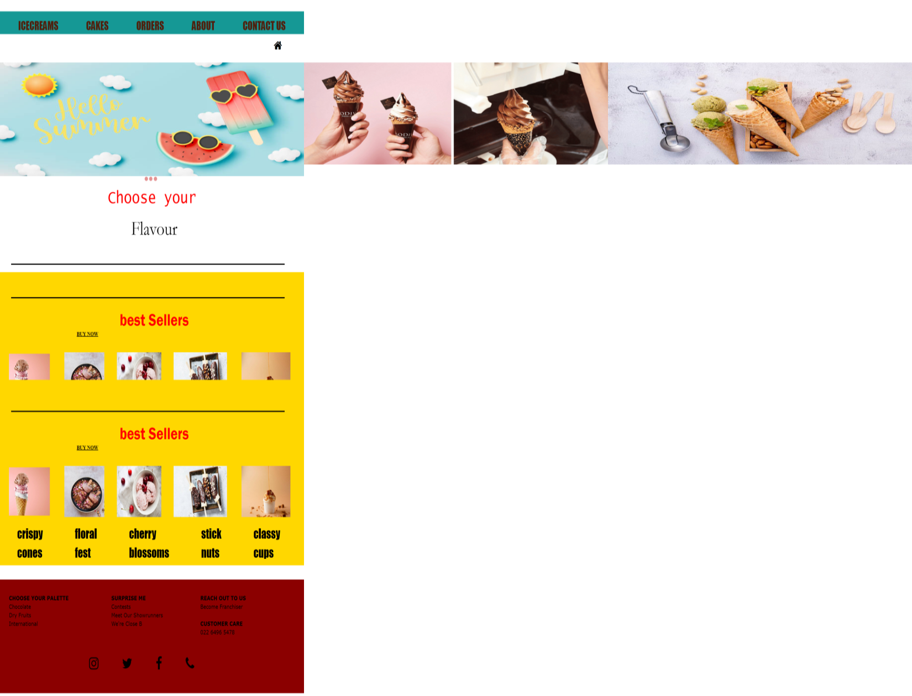

**CODING**

**<!DOCTYPE html>**

**<html>**

**<head>**

**<title>Icecream</title>**

**<link rel="stylesheet" type="text/css" href="https://www.w3schools.com/w3css/4/w3.css">**

**<link rel="stylesheet" type="text/css" href="https://cdnjs.cloudflare.com/ajax/libs/font-awesome/4.7.0/css/font-awesome.min.css">**

**<!-- <link rel="stylesheet" type="text/css" href="https://www.w3schools.com/w3-colors-2021.css"> -->**

**<style type="text/css">**

**#main2{background:#159895;border: 2px width: 200px;height: 80px;}**

**ul{**

**display: flex; padding: 20px;justify-content: space-around;list-style-type: none font-family: Impact;font-size: 40px;}**

**ul li a{text-decoration: none;color: #4F200D;}**

**ul li a:hover{background: #EAC7C7;}**

**.image-container{/*border: 2px solid black;*/height: 100;width: 300vw; padding: 0; background-color: pink;clear: both;display: flex; position: relative;**

**-webkit-transition: left 2s; -moz-transition: left 2s; -o-transition: left 2s; transition: left 2s;}**

**.slide{/*height: 400px;width: 100%;*/ float: left; margin: 0px; padding: 0px; position: relative; width: 100vw; height: 100%;}**

**#slide-1:target ~ .image-container { left: 0px; }**

**#slide-2:target ~ .image-container { left: -100vw;}**

**#slide-3:target ~ .image-container { left: -200vw; }**

**.buttons{ position: relative; bottom: 0px; width: 120%; transform: translate(650px,0px); }**

**.buttons a{ display: inline-block;height: 15px; width: 15px; border-radius: 50px; background-color: #E49393;}**

**#h1{font-size: 60px;text-align: center;font-family: Lucida Console;color: red;}**

**#p1{text-align: center;font-size:70px;transform: translate(10px,-60px);font-family: Garamond;}**

**#div2{/*border: 2px solid black; */height: 998px;width: 100%;/*transform: translate(0px,-100px);*/background: #FFD700;}**

**#pic2{/*border: 2px solid red;*/ transform: translate(70px,80px);border-radius: 10px;}**

**#pic3{/*border: 2px solid red;*/transform: translate(140px,80px);border-radius: 10px;}**

**#pic4{/*border: 2px solid red;*/transform: translate(200px,80px);border-radius: 10px;}**

**#div3{/*border: 2px solid black;*/width: 100%;height: 100px;transform: translate(0px,80px);}**

**#u1{ font-size: 40px; padding: 10px; font-family: Brush Script MT;}**

**#u1 li a{ text-decoration: none;color: black; }**

**#u1 li a:hover{ background: #FFB84C; }**

**#p2{text-align: center; padding: 160px; font-size: 60px; color: red;font-family: Franklin Gothic Medium; transform: translate(10px,-40px); }**

**#hr{ height: 2px; width: 90%; border: 2px solid black; transform: translate(50px,150px); }**

**#hr2{ height: 2px; width: 90%; border: 2px solid black; transform: translate(50px,-60px); }**

**#p6{ transform: translate(40px,-220px);}**

**#p7{ transform: translate(100px,-220px); height: 180px; width: 180px;}**

**#p8{ transform: translate(150px,-220px); height: 180px; width: 200px; }**

**#p9{ transform: translate(200px,-220px);width: 240px; height: 180px;}**

**#p10{ transform: translate(260px,-220px); width: 220px; height: 180px; }**

**#flavour{ transform: translate(-15px,-260px);font-size: 45px; }**

**.hov:hover{-webkit-transform: scale(0.8);-ms-transform: scale(0.8) transform: scale(0.8); transition: 2s ease;**

**#last{ height: 400px; width: 100%; margin-top: 50px; background: #8B0000; #ls1{ transform: translate(40px,50px); }**

**</style>**

**</head>**

**<body>**

**<div id="main2">**

**<ul><li><a href="ppp.html">ICECREAMS</a></li>**

**<li><a href="cakes.html">CAKES</a></li>**

**<li> <a href="orders.html">ORDERS</a></li>**

**<li> <a href="about.html">ABOUT</a></li>**

**<li> <a href="contact.html">CONTACT US</a></li>**

**</ul>**

**<!-- <div class="slider">**

**<a href="slide1"></a>**

**<a href="slide2"></a>**

**<a href="slide3"></a>**

**<div class="slides">**

**<div id="slide-1">1</div>**

**<div id="slide-2">1</div><div id="slide-3">1</div>**

**</div></div> -->**

**<a href="index.html"><i class="fa fa-home" style=" font-size: 40px; transform: translate(1230px,-40px);"></i> </a>**

**<div class="slider">**

**<span id="slide-1"></span>**

**<span id="slide-2"></span>**

**<span id="slide-3"></span>**

**<div class="image-container"><img src="crea.jpg" class="slide" style="width: 100%; height: 400px;"> <img src="ne5.png" class="slide" style="width: 100%; height: 400px;"> <img src="ne4.jpg" class="slide" style="width: 100%; height: 40 </div>**

**<div class="buttons">**

**<a href="#slide-1"></a> <a href="#slide-2"></a> <a href="#slide-3"></a> </div></div>**

**<h1 id="h1">Choose your</h1><p id="p1">Flavour</p>**

**<div id="hr2"></div>**

**<div id="div2"><img src="ch.jpg" id="pic2" class="w3-hover-sepia"> <img src="dry.jpg" id="pic3" class="w3-hover-sepia"><img src="Fruits.jpg" id="pic4" class="w3-hover-sepia">**

**<div id="div3"><ul id="u1"><li><a href="flavour.html">CHOCOLATE</a></li>**

**<li><a href="flavour.html">DRY FRUITS</a></li>**

**<li><a href="flavour.html">INTERNATIONAL</a></li></ul>**

**</div>**

**<div id="hr"></div>**

**<p id="p2">best Sellers</p>**

**<a href="contact.html"> <div style="text-align: center; transform: translate(-290px,-270px); font-size: 20px;font-family: comic sans; cursor: pointer;" class="w3-hover-red"><b>BUY NOW</b></div></a>**

**<div class="hov">**

**<img src="c.jpg" id="p6">**

**<img src="coo.jpg" id="p7">**

**<img src="o.jpg" id="p8">**

**<img src="cup.jpg" id="p9">**

**<img src="cu.jpg" id="p10">**

**<div><ul id="flavour">**

**<li>crispy <br>cones</li>**

**<li>floral <br>fest</li>**

**<li>cherry <br>blossoms</li>**

**<li>stick <br>nuts</li>**

**<li>classy <br>cups</li> </ul></div></div></div>**

**<div id="last">**

**<div id="ls1" style="color: black; font-size: 20px; "><b style="color: black;">CHOOSE YOUR PALETTE </b> <br>**

**Chocolate <br>**

**Dry Fruits <br> International <br </div>**

**<div style="transform: translate(500px,-70px); font-size: 20px;">**

**<b>SURPRISE ME </b><br>**

**Contests <br>**

**Meet Our Showrunners <br>**

**We're Close B**

**</div>**

**<div style="transform: translate(900px,-190px); font-size: 20px"> <b>REACH OUT TO US</b> <br> Become Franchiser </div>**

**<div style="transform: translate(900px,-160px); font-size: 20px"><b>CUSTOMER CARE</b><br> 022 6496 547 </div>**

**<a href="http://www.instagram.com"> <i class="fa fa-instagram" style="font-size: 50px;transform: translate(400px,-90px);"></i></a>**

**<a href="http://www.twitter.com"> <i class="fa fa-twitter" style="font-size: 50px;transform: translate(500px,-90px);"></i></a> <a href="http://www.facebook.com"> <i class="fa fa-facebook" style="font-size: 50px;transform: translate(600px,-90px);"></i></a>**

**<i class="fa fa-phone" style="font-size: 50px;transform: translate(700px,-90px);"></i>**

**</div>**

**<div></div></div>**

**</body></html>**

**CAKES PAGE- SCREENSHOT**

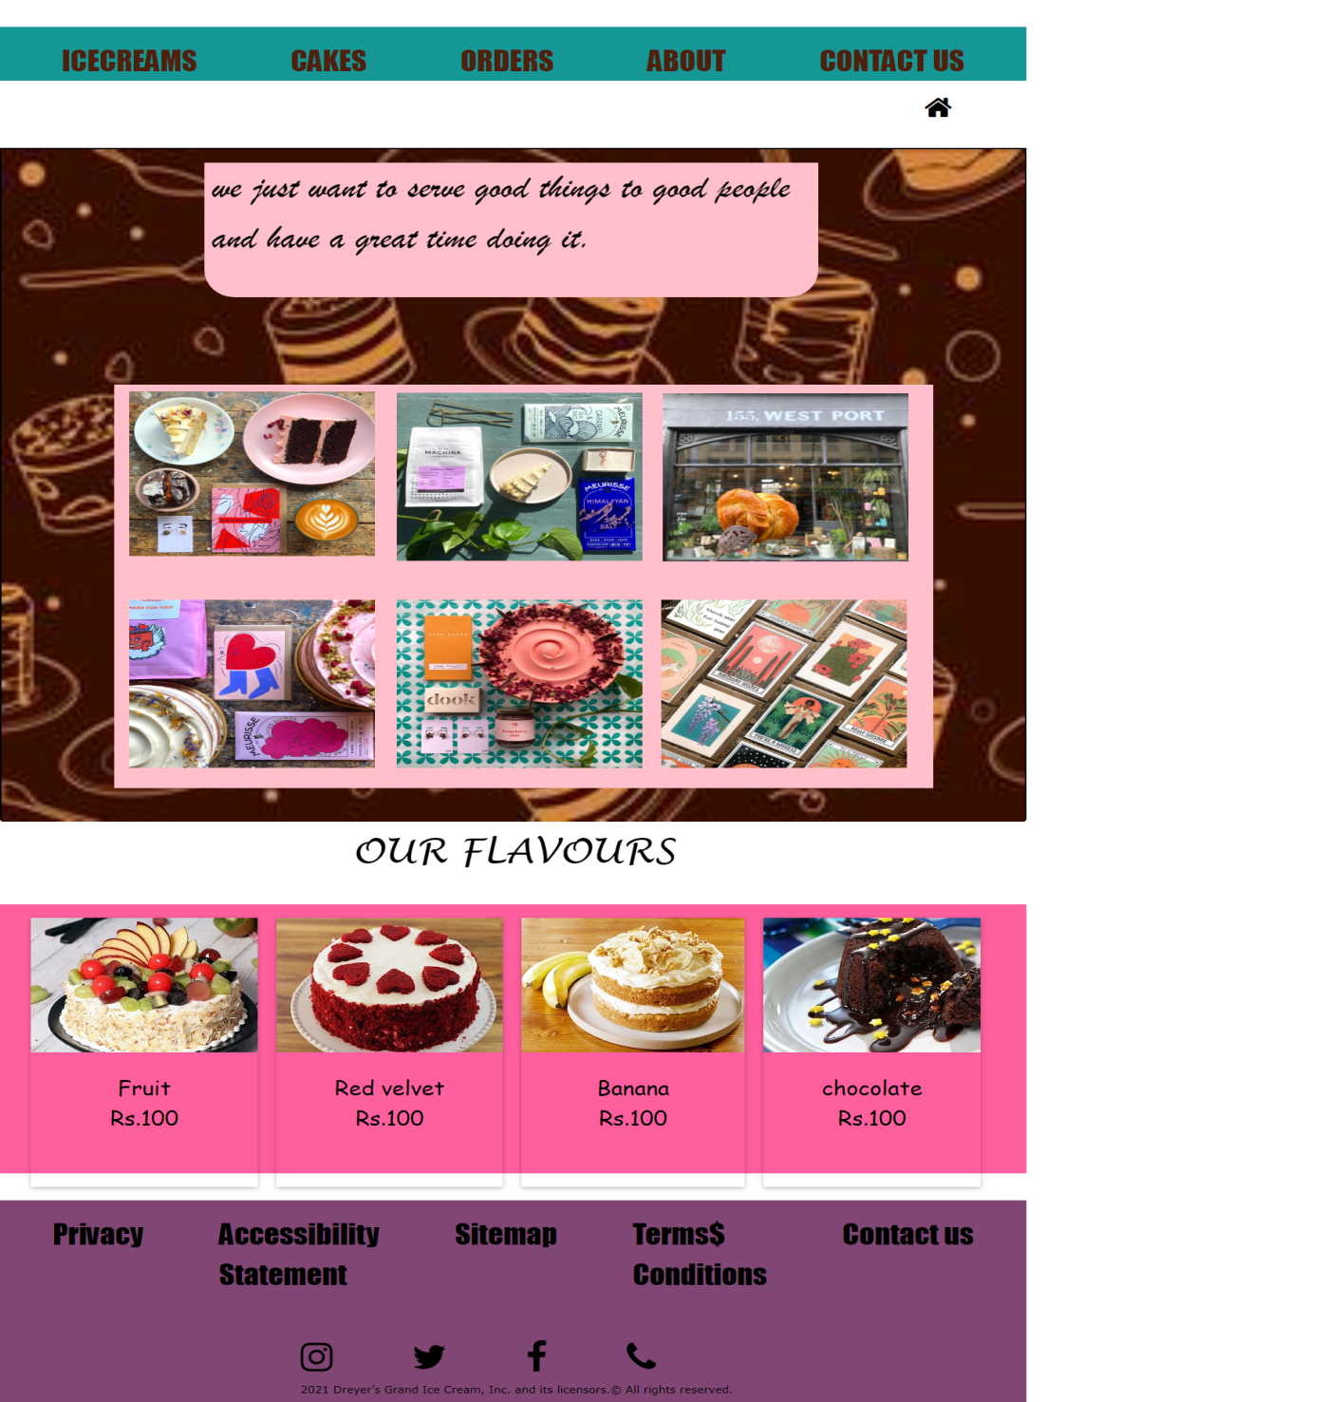

**CODING**

**<!DOCTYPE html>**

**<html>**

**<head>**

**<title></title>**

**<link rel="stylesheet" type="text/css" href="https://www.w3schools.com/w3css/4/w3.css">**

**<link rel="stylesheet" type="text/css" href="https://cdnjs.cloudflare.com/ajax/libs/font-awesome/4.7.0/css/font-awesome.min.css">**

**<style type="text/css">**

**#main2{background:#159895;border: 2px width: 200px;height: 80px;}**

**ul{display: flex;padding: 20px;justify-content: space-around;list-style-type: none;font-family: Impact;font-size: 40px;}**

**ul li a{text-decoration: none; color: #4F200D;}**

**ul li a:hover{background: #EAC7C7; }**

**#div1{ border: 2px solid black; height: 1000px; width: 100%; margin-bottom: 10px;}**

**.card{height: 400px; margin-left: 25px; margin-top: 20px;}**

**.card:hover{-webkit-transform: scale(1); transform: scale(1); -webkit-transition: .2s ease-in-out; transition: .2s ease-in-out; -webkit-transform: scale(1.3); transform: scale(1.3); }**

**#m1{height: 400px; display: flex;}**

**p4{text-align:center; font-size: 30px; font-family: Comic Sans MS;}**

**#kk{ transform: translate(400px,70px);}**

**.lineUp{animation: 2s anim-lineUp ease-out infinite;}**

**@keyframes anim-lineUp { 0% { opacity: 0; transform: translateY(80%); }**

**20% { opacity: 0; }**

**50% { opacity: 1; transform: translateY(0%);}**

**100% { opacity: 1; transform: translateY(0%)}**

**</style>**

**</head>**

**<body>**

**<div id="main2">**

**<ul><li><a href="ppp.html">ICECREAMS</a></li>**

**<li><a href="cakes.html">CAKES</a></li>**

**<li> <a href="orders.html">ORDERS</a></li>**

**<li> <a href="about.html">ABOUT</a></li>**

**<li> <a href="contact.html">CONTACT US</a></li></ul>**

**<a href="index.html"> <i class="fa fa-home" style=" font-size: 40px; transform: translate(1230px,-40px);"></i></a>**

**<div id="div1">**

**<img src="back.jpg" style="height: 1000px; width: 100%;"><div style="background: pink; height: 200px; width: 60%; transform: translate(270px,-1030px); border-radius: 0px 0px 40px 40px;"><p class="lineUp" style="font-size: 50px; font-family: Brush Script MT; margin-left: 10px;">we just want to serve good things to good people <br> and have a great time doing it.</p></div>**

**<div style="transform: translate(150px,-900px); height: 600px; width: 80%; background: pink;">**

**<div style=" height: 250px; width: 30%; transform: translate(20px,10px);"> <img src="ck10.jpg" style="height: 245px; width:100%;" class="w3-hover-sepia"></div>**

**<div style="background: red; height: 250px; width: 30%; transform: translate(376px,-238px);"> <img src="ck2.jpg" style="height: 250px; width: 100%;" class="w3-hover-sepia"></div>**

**<div style="background: red; height: 250px; width: 30%; transform: translate(20px,-180px);"><img src="ck9.jpg" style="height: 250px; width: 100%;" class="w3-hover-sepia"></div>**

**<div style="background: red; height: 250px; width: 30%; transform: translate(376px,-430px);"><img src="ck8.jpg" style="height: 250px; width: 100%;" class="w3-hover-sepia"></div>**

**<div style="background: red; height: 250px; width: 30%; transform: translate(730px,-987px);"><img src="ck7.jpg" style="height: 250px; width: 100%;" class="w3-hover-sepia"></div>**

**<div style="background: red; height: 250px; width: 30%; transform: translate(728px,-930px);"><img src="ck3.jpg" style="height: 250px; width: 100%;" class="w3-hover-sepia"></div></div></div>**

**<div style="text-align: center; font-size: 50px; font-family:Lucida Handwriting;margin-bottom: 40px;" >OUR FLAVOURS</div><div style=" height: 400px; width: 100%; background: #FF5F9E;">**

**<div class="w3-container" id="m1">**

**<div class="w3-card card"> <a href="contact.html"> <img src="fruit.jpg"></a><p class="p4">Fruit <br>Rs.100</p></div>**

**<div class="w3-card card"><a href="contact.html"><img src="red.jpg"></a><p class="p4">Red velvet <br>Rs.100</p></div>**

**<div class="w3-card card"><a href="contact.html"><img src="ca9.jpg"></a><p class="p4">Banana <br>Rs.100</p></div>**

**<div class="w3-card card"><a href="contact.html"><img src="ca10.jpg"></a> <p class="p4">chocolate <br> Rs.100</p></div></div>**

**</div>**

**<div style="height: 300PX;width: 100%; margin-top: 20px; background: #804674;">**

**<ul id="k"> <li>Privacy</li> <li>Accessibility <br> Statement</li> <li>Sitemap</li> <li>Terms$<br>Conditions</li> <li>Contact us</li>**

**</ul> <p id="kk">2021 Dreyer’s Grand Ice Cream, Inc. and its licensors.&copy All rights reserved.</p>**

**<a href="http://www.instagram.com"> <i class="fa fa-instagram" style="font-size: 50px;transform: translate(400px,-30px);"></i></a>**

**<a href="http://www.twitter.com"> <i class="fa fa-twitter" style="font-size: 50px;transform: translate(500px,-30px);"></i></a>**

**<a href="http://www.facebook.com"> <i class="fa fa-facebook" style="font-size: 50px;transform: translate(600px,-30px);"></i></a> <i class="fa fa-phone" style="font-size: 50px;transform: translate(700px,-30px);"></i></div></div></body></html>**

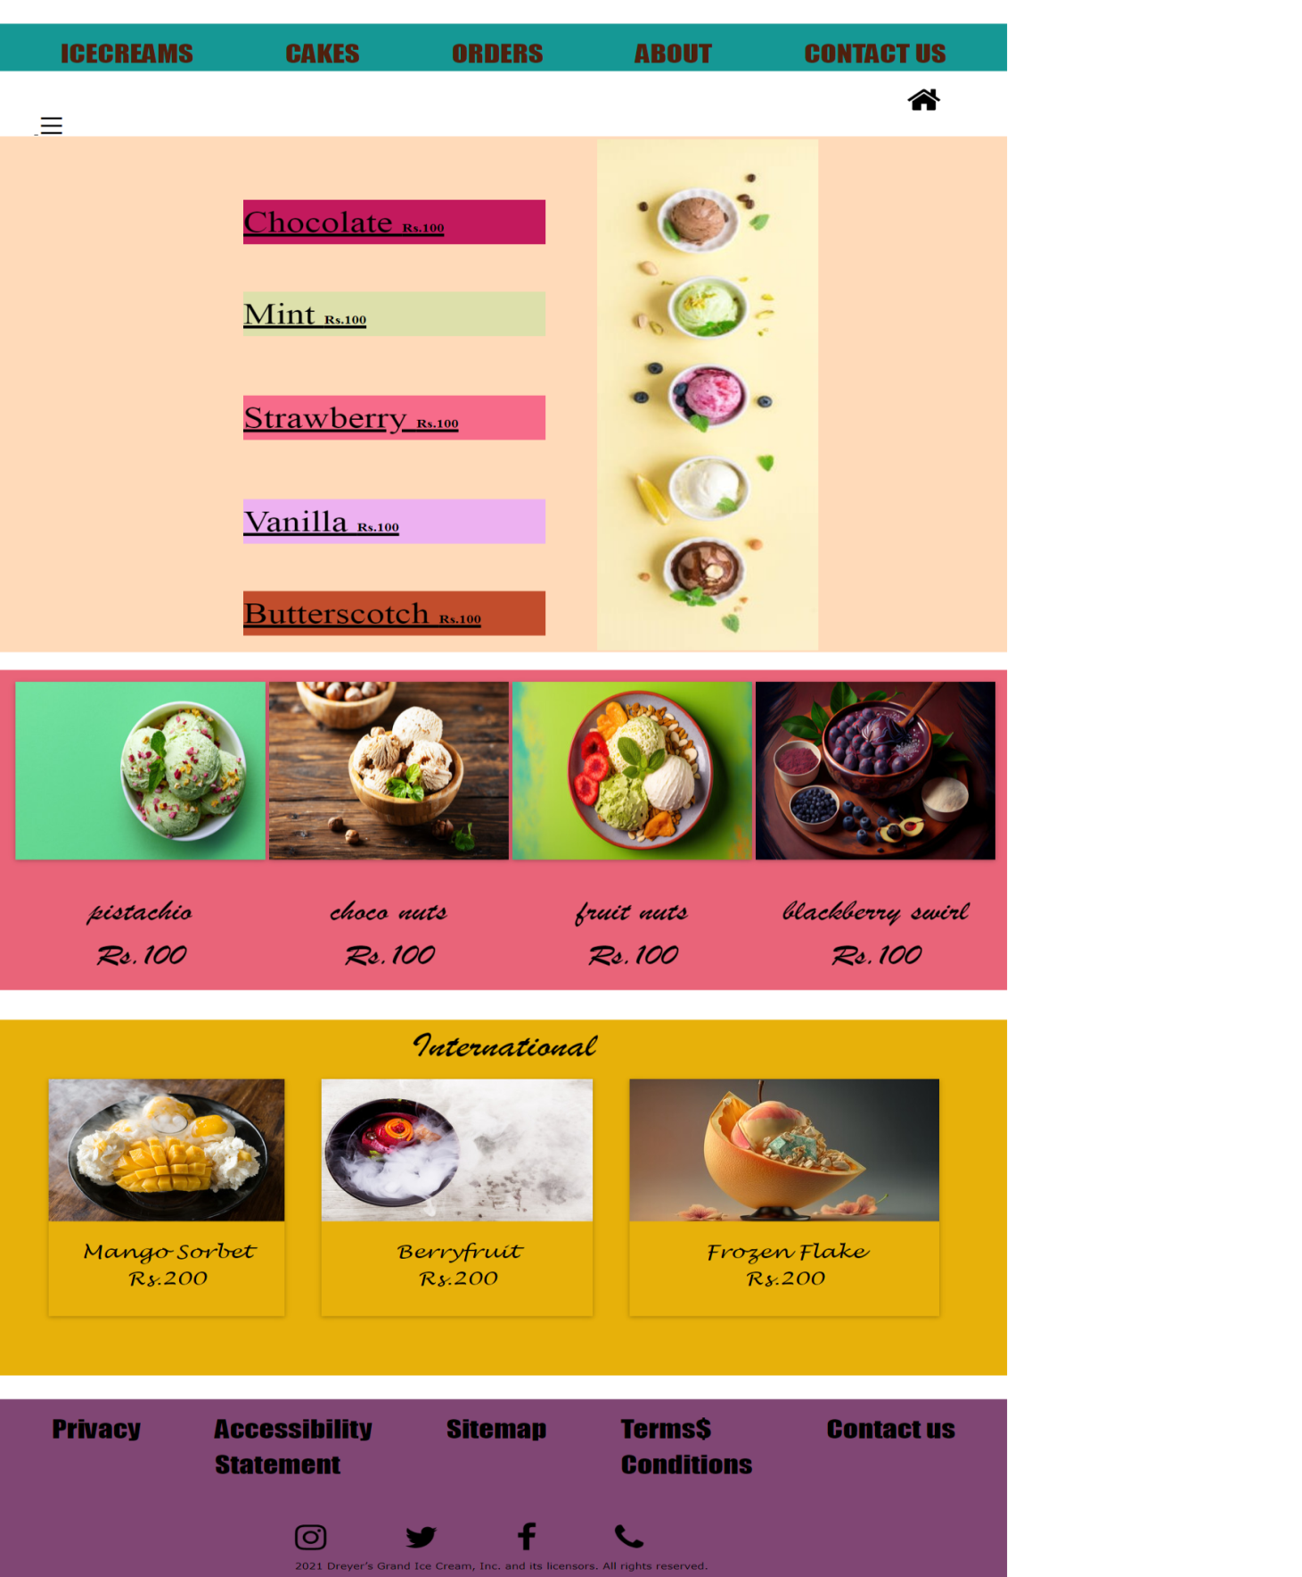

**FLAVOUR PAGE - SCREENSHOT**

**CODING**

**<!DOCTYPE html>**

**<html>**

**<head>**

**<meta charset="utf-8">**

**<meta name="viewport" content="width=device-width, initial-scale=1">**

**<title>flavour</title>**

**<link rel="stylesheet" type="text/css" href="https://www.w3schools.com/w3css/4/w3.css">**

**<link rel="stylesheet" type="text/css" href="https://cdnjs.cloudflare.com/ajax/libs/font-awesome/4.7.0/css/font-awesome.min.css">**

**<style type="text/css">**

**#main2{background:#159895; border: 2px ; width: 200px; height: 80px;}**

**ul{display: flex; padding: 20px; justify-content: space-around; list-style-type: none; font-family: Impact;**

**font-size: 40px; }**

**ul li a{text-decoration: none; color: #4F200D; }**

**ul li a:hover{background: #EAC7C7; }**

**#pict1{width: 300px; margin-left: 10px; margin-top: 5px; transform: translate(800px,0px); }**

**#d1{ height: 870px; width: 100%; /*border: 2px solid black;*/background:peachpuff; transform: translate(0px,-10px);}**

**#d2{height: 800px; width: 30%;/*border: 2px solid black;*/ font-size: 50px; transform: translate(320px,-830px);cursor: pointer;}**

**text:hover{ color: #ffee10; box-shadow: 0 0 5px #ffee10; text-shadow: 0 0 5px #ffee}**

**#d3{ /*border: 2px solid black;*/ height: ; width: 100%;margin-top: 20px; background: #E96479;**

**display: flex; }**

**.hi{ margin-top: 20px; margin-bottom:20px; margin-left:5px; height: 300px; }**

**./*hi:hover{ -webkit-transform: scale(1); transform: scale(1); -webkit-transition: .2s ease-in-out; transition: .2s ease-in-out;**

**-webkit-transform: scale(1.3); transform: scale(1.3); }*/**

**.new{ margin-top: 20px; margin-bottom:20px; margin-left:7px; height: 300px; }**

**.new:hover{ -webkit-transform: scale(1); transform: scale(1);**

**-webkit-transition: .2s ease-in-out; transition: .2s ease-in-out; -webkit-transform: scale(1.3); transform: scale(1.3); }**

**.p1{ text-align: center; font-size: 50px; font-family: Brush Script MT;}**

**#d5{ height: 600px; width: 100%; /*border: 2px solid red;*/ margin-top: 50px; background: #E7B10A;**

**}**

**- .hii{ height: 400px; margin-left: 50px;’}**

**.hii:hover{ -webkit-transform: scale(1); transform: scale(1); -webkit-transition: .2s ease-in-out; transition: .2s ease-in-out; -webkit-transform: scale(1.3); transform: scale(1.); }**

**#d6{ height: 500px; display: flex; }**

**.para1{ text-align: center; font-size: 30px; font-family: Lucida Handwriting; } }**

**#k{ transform: translate(300px,30px); justify-content: space-between; }**

**#kk{ transform: translate(400px,70px); }**

**.sidenav{ height: 100%; width: 0; position: fixed; z-index: 1; top: 0; left: 0; background-color: #EDE9D5; overflow-x: hidden; transition: 0.5s; padding-top: 60px; }**

**.sidenav a { padding: 8px 8px 8px 32px; text-decoration: none; font-size: 25px; color: #818181; display: block; transition: 0.3s;}**

**.sidenav a:hover { color: #f1f1f1; }**

**.sidenav a { padding: 8px 8px 8px 32px; text-decoration: none; font-size: 25px; color: #818181; display: block; transition: 0.3s;**

**}**

**.sidenav a:hover { color: #f1f1f1; }**

**@media screen and (max-height: 450px) { .sidenav {padding-top: 15px;}.sidenav a {font-size: 18px;}}**

**.flavour:hover{ background: #9E4784; cursor: pointer; }**

**.flavour2:hover{ background: #7DB9B6; cursor: pointer; }**

**.flavour3:hover{ background: #FDD36A; cursor: pointer; }**

**</style>**

**</head>**

**<body>**

**<div id="main2">**

**<ul>**

**<li><a href="ppp.html">ICECREAMS</a></li>**

**<li><a href="cakes.html">CAKES</a></li>**

**<li> <a href="orders.html">ORDERS</a></li>**

**<li> <a href="about.html">ABOUT</a></li>**

**<li> <a href="contact.html">CONTACT US</a></li></ul>**

**<a href="index.html"> <i class="fa fa-home" style=" font-size: 50px; transform: translate(1230px,-40px);"></i> </a>**

**<div id="mySidenav" class="sidenav> <a href="javascript:void(0)" class="closebtn" onclick="closeNav()">&times;</a> <!-- <a href="#"><button class="w3-hover-blue" style="border-radius: 20px; background: #EB455F">Add To Cart</button></a> -->**

**<input type="button" class="w3-hover-blue" style="border-radius: 20px; background: #EA5455; margin-left: 40px; font-size: 20px; height: 60px; width: 170px;" id="btnShowMsg" value="Added to cart" onClick="showMessage()" />**

**<!-- <a href="#"><button style="height: 50px; width: 120px; border-radius: 20px; margin-left: 10px; "><i class="fa fa-plus" style="float: left;"></i>**

**<i class="fa fa-minus" style="float: right;"></i> -->**

**</button></a>**

**<p style="margin-left: 30px; font-size: 30px;"><b>FLAVOURS</b></p>**

**<p style="margin-left: 30px; font-size: 30px; color: #C92C6D;" class="flavour" id="choco" onclick="addtocart()"> Chocolate</p> <p style="margin-left: 30px; font-size: 30px; color: #C92C6D;" class="flavour" id="mint" onclick="addtocart(this.id)">Mint</p>**

**<p style="margin-left: 30px; font-size: 30px; color: #C92C6D;" class="flavour">Strawberry</p>**

**<p style="margin-left: 30px; font-size: 30px; color: #C92C6D;" class="flavour">Vanilla</p>**

**<p style="margin-left: 30px; font-size: 30px; color: #C92C6D;"class="flavour">Butterscotch</p>**

**<p style="margin-left: 30px; font-size: 30px;"><b>Dryfruits</b></p>**

**<p style="margin-left: 30px; font-size: 30px; color:#0F6292;" class="flavour2">Pistachio</p>**

**<p style="margin-left: 30px; font-size: 30px; color:#0F6292;" class="flavour2">Choco nuts</p>**

**<p style="margin-left: 30px; font-size: 30px; color:#0F6292;" class="flavour2">Fruit nuts</p>**

**<p style="margin-left: 30px; font-size: 30px; color:#0F6292;" class="flavour2">Blackberry Swirl</p>**

**<p style="margin-left: 10px; font-size: 30px;"><b>International</b></p>**

**<p style="margin-left: 10px; font-size: 30px;color: #FF8B13;" class="flavour3">Mango Sorbet</p>**

**<p style="margin-left: 30px; font-size: 30px; color: #FF8B13;" class="flavour3">Berryfruit</p>**

**<p style="margin-left: 30px; font-size: 30px; color: #FF8B13;" class="flavour3">Frozen Flake</p> </div>**

**<span style="font-size:40px; margin-bottom: 10px; cursor:pointer" onclick="openNav()">&#9776; </span>**

**<div id="d1"><img src="co3.jpg" id="pict1">**

**<div id="d2"><a href="orders.html"><div style="transform: translate(10px,70px);font-family: Ink Free; background: #c3195d;" class="text">Chocolate <b style="font-size: 20px;">Rs.100</b></div></a>**

**<a href="orders.html"><div style="transform: translate(10px,150px);font-family: Ink Free; background: #dde0ab;" class="text">Mint <b style="font-size: 20px;">Rs.100</b></div></a>**

**<a href="orders.html"><div style="transform: translate(10px,250px);font-family: Ink Free; background:#f76b8a;" class="text">Strawberry <b style="font-size: 20px;">Rs.100</b></div></a>**

**<a href=" orders.html"><div style="transform: translate(10px,350px);font-family: Ink Free; background: #edb1f1;" class="text">Vanilla <b style="font-size: 20px;">Rs.100</b></div></a>**

**<a href=" orders.html"><div style="transform: translate(10px,430px);font-family: Ink Free;background: #c24d2c;"class="text">Butterscotch <b style="font-size: 20px;">Rs.100</b></div></a>**

**</div> </div>**

**<div class="w3-container" id="d3"> <div class="w3-card w3-hover-shadow hi"><img src="d2.jpg" class="new" style="height: 100%; width: 100%;">**

**<p class="p1">pistachio <br>Rs.100</p></div> <div class="w3-card w3-hover-shadow hi"> <img src="d3.jpg" class="new" style=" height: 100%; width: 100%"><p class="p1">choco nuts <br>Rs.100</p></div> <div class="w3-card w3-hover-shadow hi"><img src="d5.jpg" class="new" style=" height: 100%;width: 100%;"> <p class="p1">fruit nuts <br>Rs.100</p></div> <div class="w3-card w3-hover-shadow hi"><img src="d7.jpg" class="new" style="height: 100%; width: 100%;"><p class="p1">blackberry swirl <br>Rs.100</p></div></div>**

**<div id="d5"> <h1 style="text-align:center; font-size:60px; font-family: Brush Script MT;">International</h1> <div class="w3-container" id="d6"> <div class="w3-card w3-hover-shadow hii" ><img src="d.jpg"> <p class="para1">Mango Sorbet <br>Rs.200</p></div> <div class="w3-card w3-hover-shadow hii"><img src="i5.jpg"> <p class="para1">Berryfruit <br>Rs.200</p></div><div class="w3-card w3-hover-shadow hii"><img src="i2.jpg> <p class="para1">Frozen Flake <br>Rs.200</p></div> </div> <div style="height: 300PX;width: 100%; margin-top: 20px; background: #804674;">**

**<ul id="k> <li>Privacy</li> <li>Accessibility <br> Statement</li>**

**<li>Sitemap</li> <li>Terms$<br>Conditions</li> <li>Contact us</li> </ul>**

**<p id="kk">2021 Dreyer’s Grand Ice Cream, Inc. and its licensors. All rights reserved.</p> <a href="http://www.instagram.com"> <i class="fa fa-instagram" style="font-size: 50px;transform: translate(400px,-30px);"></i></a> <a href="http://www.twitter.com"> <i class="fa fa-twitter" style="font-size: 50px;transform: translate(500px,-30px);"></i></a> <a href="http://www.facebook.com"> <i class="fa fa-facebook" style="font-size: 50px;transform: translate(600px,-30px);"></i></a> <i class="fa fa-phone" style="font-size: 50px;transform: translate(700px,-30px);"></i></a> </div></div></div>**

**<script>**

**function openNav() { document.getElementById("mySidenav").style.width = "250px";}**

**function closeNav() { document.getElementById("mySidenav").style.width = "0";}**

**</script>**

**<script type="text/javascript">**

**function showMessage() { alert("Item added to cart"); }**

**</script>**

**</body>**

**</html>**

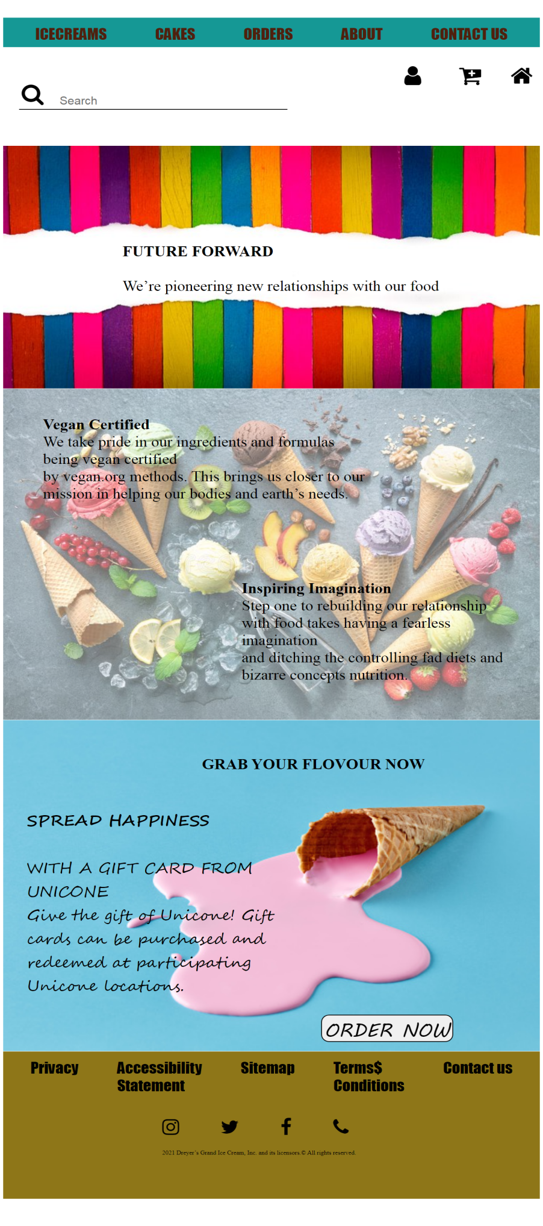

**ORDER PAGE – SCREENSHOT**

**CODING**

**<!DOCTYPE html>**

**<html>**

**<head><title>order</title>**

**<link rel="stylesheet" type="text/css" href="https://cdnjs.cloudflare.com/ajax/libs/font-awesome/4.7.0/css/font-awesome.min.css">**

**<style type="text/css">**

**#main2{background:#159895;border: 2px width:100%;height: 80px;}**

**ul{display: flex; padding: 20px; justify-content: space-around; list-style-type: none; font-family: Impact;**

**font-size: 40px;}ul li a{text-decoration: none; color: #4F200D;}**

**ul li a:hover{ background: #EAC7C7;}**

**#m1{/*border: 2px solid red;*/ height: 400px; width: 100%;}**

**#kk{ transform: translate(400px,90px);/*border: 2px solid red;*/ width: 60%; }**

**.button:hover{ color: yellow; background: #9E4784; }**

**#myDiv{/*border: 2px solid red;*/ height: 300px; width: 50%; transform: translate(100px,-460px);**

**background: #EDE9D5; border-radius: 20px;}**

**.b2:hover{ background: #539165;}**

**</style>**

**</head>**

**<body>**

**<div id="main2">**

**<ul>**

**<li><a href="ppp.html">ICECREAMS</a></li><li><a href="cakes.html">CAKES</a></li><li> <a href="orders.html">ORDERS</a></li>**

**<li> <a href="about.html">ABOUT</a></li>**

**<li> <a href="contact.html">CONTACT US</a></li></ul>**

**<div style="height: 200px; width: 100%; margin-bottom: 20px;">**

**<a href="contact.html"><i class="fa fa-user" style="font-size: 60px; transform: translate(1009px,0px); color: black;"></i></a>**

**<a href="contact.html"><i class="fa fa-cart-plus" style="font-size:60px; transform: translate(1100px,0px); color: black;"></i></a>**

**<a href="index.html"><i class="fa fa-home" style="font-size: 60px; transform: translate(1170px,0px); color: black;"></i></a>**

**<i class="fa fa-search" style="font-size: 60px; transform: translate(-120px,50px);"></i>**

**<div style="height:2px;width: 50%; transform: translate(40px,60px); background: black; "><input type="text" name="" placeholder="Search"style="transform: translate(100px,-40px);border: none;font-size: 30px;"></div></div>**

**<div id="m1"><img src="n3.jpg" style="width: 100%;"><div style="transform: translate(300px,-400px); font-size: 40px; width: 60%;"><b>FUTURE FORWARD</b> <br> <br>**

**We’re pioneering new relationships with our food </div></div>**

**<div style= "height: 900px; width: 100%; margin-top: 260px;">**

**<img src="nw.jpg" style="width:100%;opacity: 60%;">**

**<p style="transform: translate(100px,-870px); width: 60%; font-size: 40px;"> <b>Vegan Certified</b> <br>**

**We take pride in our ingredients and formulas being vegan certified <br> by vegan.org methods. This brings us closer to our mission in helping our bodies and earth’s needs.</p>**

**<p style="transform: translate(600px,-700px); width: 50%; font-size: 40px;"> <b>Inspiring Imagination</b> <br> Step one to rebuilding our relationship with food takes having a fearless imagination <br>and ditching the controlling fad diets and bizarre concepts nutrition. </p></div>**

**<div style="height: 400px; width: 100%;"><img src="n2.jpg" style="width: 100%;"><p style="transform: translate(60px,-700px);width: 50%; font-size: 40px; font-family: Segoe Script;"><b>SPREADHAPPINESS</b> <br> <br> WITH A GIFT CARD FROM UNICONE <br> Give the gift of Unicone! Gift cards can be purchased and redeemed at participating Unicone locations.</p>**

**<p style="transform: translate(500px,-1400px); font-size: 40px;v font-family: Lucida Handwriting; width: 60%;"><B>GRAB YOUR FLOVOUR NOW</B></p></div>**

**<div style=" height: 400px; width: 100%; margin-top: 500px; background: #8E7618;">**

**<ul id="k">**

**<li>Privacy</li>**

**<li>Accessibility <br> Statement</li>**

**<li>Sitemap</li>**

**<li>Terms$<br>Conditions</li>**

**<li>Contact us</li> </ul>**

**<p id="kk">2021 Dreyer’s Grand Ice Cream, Inc. and its licensors.&copy All rights reserved.</p><a href="http://www.instagram.com"> <i class="fa fa-instagram" style="font-size: 50px; color:black;transform: translate(400px,-30px); "></i></a> <a href="http://www.twitter.com"> <i class="fa fa-twitter" style="font-size: 50px;color:black;transform: translate(500px,-30px);"></i></a> <a href="http://www.facebook.com"> <i class="fa fa-facebook" style="font-size: 50px;transform: translate(600px,-30px); color: black;"></i></a> <i class="fa fa-phone" style="font-size: 50px;transform: translate(700px,-30px);"></i></div>**

**<a href="contact.html"><button style="font-size: 50px;transform: translate(800px,-500px);border-radius: 20px; height: 74px; font-family: MV Boli;" class="button">ORDER NOW</button></a></div>**

**<script>**

**localstorage.getItem()**

**</script>**

**</body>**

**</html>**

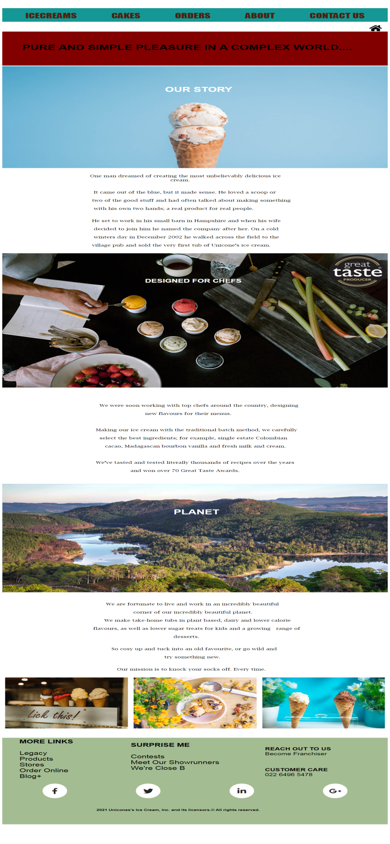

**ABOUT PAGE - SCREENSHOT**

**CODING**

**<!DOCTYPE html>**

**<html>**

**<head>**

**<title>order</title>**

**<link rel="stylesheet" type="text/css" href="https://cdnjs.cloudflare.com/ajax/libs/font-awesome/4.7.0/css/font-awesome.min.css">**

**<link rel="stylesheet" href="https://use.fontawesome.com/releases/v5.6.3/css/all.css" integrity="sha384-UHRtZLI+pbxtHCWp1t77Bi1L4ZtiqrqD80Kn4Z8NTSRyMA2Fd33n5dQ8lWUE00s/" crossorigin="anonymous">**

**<style type="text/css">**

**#main{/*border: 2px solid black;*/ height: 4500px; width: 100%; }**

**#main2{background:#159895; border: 2px ; width:100%; height: 80px; }**

**ul{display: flex; padding: 20px; justify-content: space-around; list-style-type: none; font-family: Impact; font-size: 40px;}**

**ul li a{text-decoration: none; color: #4F200D;}**

**ul li a:hover{ background: #EAC7C7;}**

**#h{ height: 200px; width: 100%; font-size: 21px; margin-top: 50px; }**

**.canva{ height: 700px; width: 100%; }**

**#foot{width: 98%; height: 300px; /*border: 1px solid black;*/ transform: translate(10px,850px);**

**background: pink;}**

**#k{transform: translate(300px,30px); word-spacing: 50px;}**

**#kk{transform: translate(400px,80px); width: 60%;**

**}**

**@import url('https://fonts.googleapis.com/css2?family=Play&display=swap');**

**.wrapper.two { background-color: #820000; font-size: 6rem; font-family: "Play", sans-serif;}**

**.neon h1 { margin: 1rem auto; animation: neon 1s ease infinite;}**

**@keyframes neon { 0%, 100% { text-shadow: 0 0 10px #ef00e3a8, 0 0 20px #ef00e3a8, 0 0 20px #ef00e3a8, 0 0 20px #ef00e3a8, 0 0 2px #fed128, 2px 2px 2px #806914; color: #f5efcb; }**

**50% { text-shadow: 0 0 2px #800e0b, 0 0 5px #800e0b, 0 0 5px #800e0b, 0 0 5px #800e0b, 0 0 2px #800e0b, 4px 4px 2px #40340a;**

**color: #eda0d3; }}**

**.assets { display: none; }**

**#contain{ display: flex; border: 2px solid red;* }**

**.card{margin: 10px; }**

**.card:hover{ background: #E8A0BF; }**

**#contain:hover{ background: #F5F3C1; }**

**ul1 { display: flex; position: absolute; top: 50%; left: 50%; transform: translate(-50%, -50%);}**

**.ul1 li { list-style: none;}**

**.ul1 li a { width: 80px; height: 80px; background-color: #fff; text-align: center; line-height: 80px; font-size: 35px; margin: 250px 10px; display: block; border-radius: 50%; position: relative; overflow: hidden; border: 3px solid #fff; z-index: 1;}**

**.ul1 li a .icon { position: relative; color: #262626; transition: .5s; z-index: 3;}**

**.ul1 li a:hover .icon { color: #fff; transform: rotateY(360deg);}**

**.ul1 li a:before { content: ""; position: absolute; top: 100%; left: 0; width: 100%; height: 100%; background: #f00; transition: .5s; z-index: 2;}**

**.ul1 li a:hover:before { top: 0;}**

**.ul1 li:nth-child(1) a:before{ background: #3b5999;}**

**.ul1 li:nth-child(2) a:before{ background: #55acee;}**

**.ul1 li:nth-child(3) a:before { background: #0077b5;}**

**.ul1 li:nth-child(4) a:before { background: #dd4b39;}**

**</style>**

**</head>**

**<body>**

**<div id="main">**

**<div id="main2">**

**<ul>**

**<li><a href="ppp.html">ICECREAMS</a></li>**

**<li><a href="cakes.html">CAKES</a></li>**

**<li> <a href="order.html">ORDERS</a></li>**

**<li> <a href="about.html">ABOUT</a></li>**

**<li> <a href="contact.html">CONTACT US</a></li</ul>**

**<a href="index.html"> <i class="fa fa-home" style="float: right;margin-right: 20px; margin-top: -30px; color: black; font-size: 40px;"></i> </a>**

**<div class="wrapper two" id="h"><div class="neon">**

**<h1 style="padding: 70px;">PURE AND SIMPLE PLEASURE IN A COMPLEX WORLD....</h1></div>**

**<div style=" height: 600px; width: 100%;">**

**<div> <img src="pr.jpg" style="height: 600px; width: 100%;"></div>**

**<div style="width: 30%; margin: -490px 570px; color:white; font-size: 40px;"><b>OUR STORY</b></div> </div>**

**<pre><p style=" transform: translate(250px,-10px); height: 460px; width: 70%; font-family: Lucida Bright;"> One man dreamed of creating the most unbelievably delicious ice cream**

**It came out of the blue, but it made sense. He loved a scoop or two of the good stuff and had often talked about making something with his own two hands; a real product for real people. He set to work in his small barn in Hampshire and when his wife decided to join him he named the company after her. On a cold winters day in December 2002 he walked across the field to the village pub and sold the very first tub of Unicone's ice cream.</p></pre>**

**<div><img src="pr1.jpg" style="width: 100%;">**

**<div style="width: 30%; color:white; transform:translate(500px,-650px); font-size: 30px;"><b>DESIGNED FOR CHEFS</b></div></div>**

**<pre><p style="font-family: Lucida Bright; transform: translate(270px,10px);height: :300px; width: 60%;"> We were soon working with top chefs around the country, designing. new flavours for their me. Making our ice cream with the traditional batch method, we carefully select the best ingredients; for example, single estate Colombian cacao, Madagascan bourbon vanilla and fresh milk and cream. We've tasted and tested literally thousands of recipes over the years and won over 70 Great Taste Awards. </p></pre>**

**<div><img src="pr3.jpg" style="width: 100%;margin-top: 30px; "> <div style="width: 30%; color:white; transform:translate(600px,-500px); font-size: 40px;"><b>PLANET</b></div> </div>**

**<pre><p style="font-family: Lucida Bright; width: 60%; height: 400px; transform: translate(280px,-13px);"> We are fortunate to live and work in an incredibly beautiful <br> corner of our incredibly beautiful planet. <br> We make take-home tubs in plant based, dairy and lower calorie flavours, as well as lower sugar treats for kids and a growing range of desser So cosy up and tuck into an old favourite, or go wild and try something new. Our mission is to knock your socks off. Every time.**

**</p></pre>**

**<div id="contain"><div class="card">**

**<img src="https://images.unsplash.com/photo-1627373717516-0f4bb24c487d?ixlib=rb-4.0.3&ixid=MnwxMjA3fDB8MHxzZWFyY2h8NDZ8fGljZWNyZWFtfGVufDB8fDB8fA%3D%3D&auto=format&fit=crop&w=500&q=60" style="width:100%; height: 300px;"> </div>**

**<div class="card"><img src="https://images.unsplash.com/photo-1542895348-dc7e72b8ec42?ixlib=rb-4.0.3&ixid=MnwxMjA3fDB8MHxzZWFyY2h8NTZ8fGljZWNyZWFtfGVufDB8fDB8fA%3D%3D&auto=format&fit=crop&w=500&q=60" style="width:100%; height: 300px;"></div>**

**<div class="card"><img src="https://images.unsplash.com/photo-1563252781-2f76e089e889?ixlib=rb-4.0.3&ixid=MnwxMjA3fDB8MHxzZWFyY2h8Mjl8fGljZWNyZWFtfGVufDB8fDB8fA%3D%3D&auto=format&fit=crop&w=500&q=60" style="width:100%; height: 300px;"></div> </div>**

**<div style=" height: 510px; width:100%;background: #A4BC92;">**

**<ul class="ul1"> <li><a href="#"> <i class="fab fa-facebook-f icon"></i> </a> </li> <li> <a href="#"><i class="fab fa-twitter icon"></i></a> </li> <li>**

**<a href="#"><i class="fab fa-linkedin-in icon"></i></a></li> <li>**

**<a href="#"><i class="fab fa-google-plus-g icon"></i></a></li> </ul>**

**<p style="transform: translate(270px,-310px);width: 50%; font-size: 17px; padding: 60px;"><b>2021 Unicones's Ice Cream, Inc. and its licensors.&copy All rights reserved.</b></p>**

**<div style=" height:260px; width: 22%; transform: translate(50px,-840px);">**

**<p style="padding:10px; font-size: 30px;"><b>MORE LINKS</b><br><br>**

**Legacy <br>**

**Products <br>**

**Stores <br>**

**Order Online <br>**

**Blog+</p></div>**

**<div style=" height:260px; width: 30%; transform: translate(450px,-1100px);"> <p style=" font-size: 30px;"><b>SURPRISE ME </b><br><br>**

**Contests <br> Meet Our Showrunners <br> We're Close B </p> </div>**

**<div style=" height:260px; width: 25%; transform: translate(900px,-1380px);">**

**<p style="padding:20px; font-size: 25px;"><b style=>REACH OUT TO US</b> <br> Become Franchiser</p> <p style="padding:20px; font-size: 25px;"><b>CUSTOMER CARE</b> <br> 022 6496 5478</p> </div></div>**

**</div>**

**</body>**

**</html>**

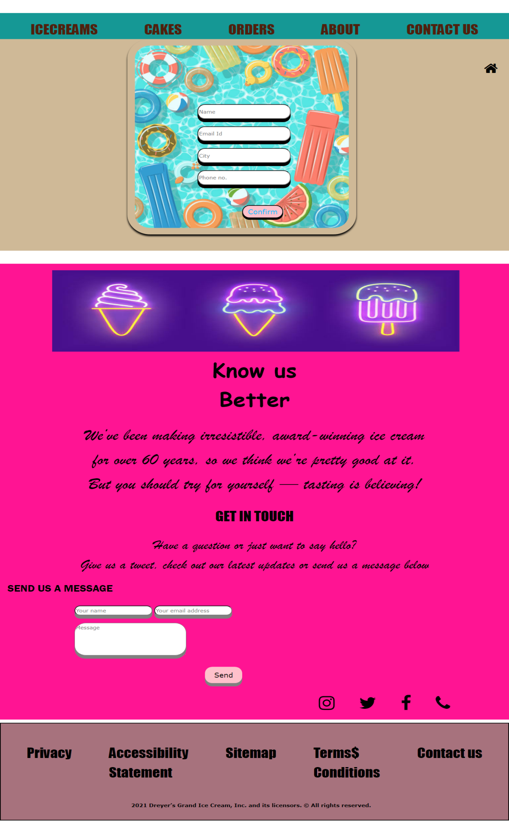

**CONTACT PAGE - SCREENSHOT**

**CODING**

**<!DOCTYPE html>**

**<html>**

**<head>**

**<!DOCTYPE html>**

**<html>**

**<head>**

**<meta charset="utf-8">**

**<title>form</title>**

**<link rel="stylesheet" type="text/css" href="https://www.w3schools.com/w3css/4/w3.css">**

**<link rel="stylesheet" type="text/css" href="https://cdnjs.cloudflare.com/ajax/libs/font-awesome/4.7.0/css/font-awesome.min.css">**

**<style type="text/css">**

**/*@media(max-width:550px){**

**img{width: 100%;}**

**.form{margin-right: 100px;}}*/**

**#i{ height: 600px; width: 50%; margin-left: 25%; padding: 20px; border-radius: 10%;box-shadow: 0 5px 5px; }**

**#di{/*border: 2px solid red;*/height: 650px;background: #CFB997; }**

**.form{transform: translate(530px,-400px); border-radius: 20px; height: 45px; width: 250px;**

**box-shadow: 0 10px; }**

**input:hover{color: black; cursor: pointer; box-shadow: 0 0 5px; }**

**.button{ transform: translate(650px,-140px); border-radius: 30px; height: 40px; width: 110px; color: #00BFFF; background-color: pink; font-size: 20px; cursor: pointer; box-shadow: 0 5px black;}**

**.button:hover{ background: #C71585; }**

**#know{ /*border: 2px solid black;*/ height: 1400px; width: 100%; background: #FF1493; }**

**#img1{ height: 250px; width: 80%; transform: translate(140px,20px); }**

**#h1{ text-align: center; padding: 30px; font-size: 60px; font-family: Comic Sans MS; }**

**#h2{text-align: center; font-size: 50px; font-family: Brush Script MT; }**

**#h3{text-align: center; padding: 30px;font-size: 40px; font-family: Impact;}**

**#h4{text-align: center; font-size: 40px; font-family: Brush Script MT; }**

**#h5{ text-align: left; padding: 20px; font-size: 30px; font-family: Franklin Gothic Medium; }**

**.message1{ transform: translate(200px,10px); border-radius: 30px; height: 30px; box-shadow: 0 10px grey; }**

**#main2{background:#159895; border: 2px ;width: 200px; height: 80px;}**

**ul{display: flex; padding: 20px; justify-content: space-around; list-style-type: none; font-family: Impact;**

**font-size: 40px;}**

**ul li a{text-decoration: none; color: #4F200D;}**

**ul li a:hover{background: #EAC7C7;}**

**#mains{/*border: 2px solid red;*/ height: 2500px; width: 100%;}**

**</style>**

**</head>**

**<body>**

**<div id="mains">**

**<div id="main2">**

**<ul>**

**<li><a href="ppp.html">ICECREAMS</a></li>**

**<li><a href="cakes.html">CAKES</a></li> <li> <a href="orders.html">ORDERS</a></li> <li> <a href="about.html">ABOUT</a></li><li> <a href="contact.html">CONTACT US</a></li></ul>**

**<!-- <div id="i"><img src="q.jpg" id="e"></div> -->**

**<a href="index.html" <i class="fa fa-home" style="float: right;margin-right: 20px; padding: 10px; font-size: 40px;"class="w3-hover-white;"></i></a></div>**

**<div id="di"><form name="myForm" method="post" onsubmit="return submitClick();"><img src="cr.jpg" style=" width: 45%;" id="i"><div><input type="text" name="user_name" placeholder="Name" required class="form" ></div><br><div><input type="text" name="user_email" placeholder="Email Id" required class="form"></div><br><div><input type="text" name="City" placeholder="City" required class="form" ></div><br><div><input type="number" name="user_phone" placeholder="Phone no." required class="form"></div><br></div><!-- <button class="button" ><b>Confirm</b></button> --><input class="button" type="submit" name="send" value="Confirm" onClick="submitClick( )"></form>**

**<div id="know"><img src="cream.jpg" id="img1"><div id="h1"><b>Know us <br> Better</b></div>**

**<div id="h2">We’ve been making irresistible, award-winning ice cream <br>for over 60 years, so we think we’re pretty good at it. <br> But you should try for yourself — tasting is believing!</div>**

**<div id="h3">GET IN TOUCH</div><div id="h4">Have a question or just want to say hello? <br> Give us a tweet, check out our latest updates or send us a message below </div>**

**<div id="h5">SEND US A MESSAGE</div>**

**<div><input type="text" name="" placeholder="Your name" class="message1">**

**<input type="text" name="" placeholder="Your email address" class="message1"> <br> <br>**

**<!-- <input type="text" name="" placeholder="Your message" class="message1"style="height: 100px; width: 300px;"> -->**

**<textarea placeholder="Message" style="height: 100px; width: 300px;" class="message1"></textarea></div><button style="height: 50px; width: 100px; margin-left: 550px; margin-top: 40px; border-radius: 20px;box-shadow: 0 10px gray;cursor: pointer;background: pink; font-size: 20px; " class="w3-button w3-hover-blue;"onclick="alert('Sent 😊')">Send</button>**

**<a href="http://www.instagram.com"> <i class="fa fa-instagram" style="transform: translate(200px,120px); color: black; font-size: 50px;"></i></a>**

**<a href="http://www.twitter.com"> <i class="fa fa-twitter" style="transform: translate(260px,120px); font-size: 50px;"></i></a> <a href="http://www.facebook.com"><i class="fa fa-facebook" style="transform: translate(320px,120px); font-size: 50px;"></i></a> <i class="fa fa-phone" style="transform: translate(380px,120px); font-size: 50px;"></i></div><div style="border: 2px solid black; height: 300px; width: 100%;margin-top: 10px; background: #A7727D;"><div id="foot">**

**<ul id="k"> <li>Privacy</li>**

**<li>Accessibility <br> Statement</li>**

**<li>Sitemap</li>**

**<li>Terms$<br>Conditions</li>**

**<li>Contact us</li></ul>**

**<p style="margin-left: 350px;"><b> 2021 Dreyer’s Grand Ice Cream, Inc. and its licensors. &copy All rights reserved.</b></p></div></div> </div>**

**<script>**

**function submitClick() { if (formValidation()) { alert("Thank you for your time! Your details have been submitted!"); return true; } else { return false; } }**

**function formValidation() { flag = true; if (document.myForm.user_name.value == "") { alert("Please fill in your Name!"); flag = false; }**

**// Validate letters only as Name**

**if (!/^[a-zA-Z]*$/g.test(document.myForm.user_name.value)) { alert("Enter alphabetic characters as Name!");flag = false; }**

**// Validate emails**

**if (!/^\w+([\.-]?\w+)*@\w+([\.-]?\w+)* (\.\w{2,3})+$/.test(myForm.user_email.value)) //Regular expressions to validate email { //alert("Enter Valid Email Address!"); //flag = false; }**

**// Validate Phone number**

**if (document.myForm.user_phone.value == "") { alert("Please fill in your Phone Number!"); flag = false; }**

**if (!/^[0-9]*$/g.test(myForm.user_phone.value)) { alert("Enter numeric values as Phone Number!");**

**flag = false; } return flag; } </script></body></html>**

**CREATED BY**

**PRAGYA**